VLSI Homework2

學號：B073040050

姓名：翁昌閔

------------------------------------------------------------

## Inverter

**A.【Compare the Results of Pre-simulation and Post-simulation in both Hspice and Nanosim simulation】**

**《INV_X1》**

|  |  |  |  |  |  |  |  |  |  |
| --- | --- | --- | --- | --- | --- | --- | --- | --- | --- |
| Hspice Simulation (Pre-simulation) --- INV_X1 | | | | | | | | | |
| Cload | Temp  (℃) | Process  Corner | cgtot(輸入電容) | | Propagation  Delay | Static Power  (Watts) | Dynamic Power (Watts) | | |
| **PMOS** | **NMOS** | **max** | **min** | **Avg** |
| 0.01pF | 25℃ | TT | 1.6584f | 281.6760a | 77.0811p | 127.4166p | 283.9569u | 10.5027p | 1.0308u |
| Tphl = 77.0811p  Tplh =77.0004p |

|  |  |  |  |  |  |  |  |  |  |
| --- | --- | --- | --- | --- | --- | --- | --- | --- | --- |
| Hspice Simulation (Post-simulation) --- INV_X1 | | | | | | | | | |
| Cload | Temp  (℃) | Process  Corner | cgtot(輸入電容) | | Propagation  Delay | Static Power  (Watts) | Dynamic Power (Watts) | | |
| **PMOS** | **NMOS** | **max** | **min** | **Avg** |
| 0.01pF | 25℃ | TT | 1.6584f | 281.6760a | 81.5395p | 127.3681p | 289.8434u | 6.9544p | 1.0839u |
| Tphl = 79.6064p  Tplh =81.5395p |

|  |  |  |  |  |  |  |  |  |  |  |  |
| --- | --- | --- | --- | --- | --- | --- | --- | --- | --- | --- | --- |
| Nanosim Simulation (Pre-simulation) --- INV_X1 | | | | | | | | | | | |
| Cload | Temp  (℃) | Process  Corner | Average  Capacitive  Current  (A) | Dynamic  Power  (Watts) | Average  Wasted  Current  (A) | Static  Power  (Watts) | Average  Static  Wasted  Current | Leakage  Power  (Watts) | | Average  Dynamic  Wasted  Current  (A) | Short  Power  (Watts) |
| 0.01pF | 25℃ | TT | -1.024393 uA |  | -0.014248 uA |  | -0.000018 uA |  | -0.014230 uA | |  |

|  |  |  |  |  |  |  |  |  |  |  |
| --- | --- | --- | --- | --- | --- | --- | --- | --- | --- | --- |
| Nanosim Simulation (Post-simulation) --- INV_X1 | | | | | | | | | | |
| Cload | Temp  (℃) | Process  Corner | Average  Capacitive  Current  (A) | Dynamic  Power  (Watts) | Average  Wasted  Current  (A) | Static  Power  (Watts) | Average  Static  Wasted  Current | Leakage  Power  (Watts) | Average  Dynamic  Wasted  Current  (A) | Short  Power  (Watts) |
| 0.01pF | 25℃ | TT | -1.235539 uA |  | -0.012158 uA |  | -0.000018 uA |  | -0.012139 uA |  |

**《INV_X2》**

|  |  |  |  |  |  |  |  |  |  |
| --- | --- | --- | --- | --- | --- | --- | --- | --- | --- |
| Hspice Simulation (Pre-simulation) --- INV_X2 | | | | | | | | | |
| Cload | Temp  (℃) | Process  Corner | cgtot(輸入電容) | | Propagation  Delay | Static Power  (Watts) | Dynamic Power (Watts) | | |
| **PMOS** | **NMOS** | **max** | **min** | **Avg** |
| 0.01pF | 25℃ | TT | 3.4064f | 566.8137a | 51.1272p | 42.6357p | 463.2769u | 13.4840p | 1.2819u |
| Tphl = 51.1272p  Tplh =50.2514p |

|  |  |  |  |  |  |  |  |  |  |
| --- | --- | --- | --- | --- | --- | --- | --- | --- | --- |
| Hspice Simulation (Post-simulation) --- INV_X2 | | | | | | | | | |
| Cload | Temp  (℃) | Process  Corner | cgtot(輸入電容) | | Propagation  Delay | Static Power  (Watts) | Dynamic Power (Watts) | | |
| **PMOS** | **NMOS** | **max** | **min** | **Avg** |
| 0.01pF | 25℃ | TT | 3.4064f | 566.8137a | 55.3942p | 42.5804p | 491.8860u | 14.8947p | 1.3524u |
| Tphl = 55.3942p  Tplh =53.7744p |

|  |  |  |  |  |  |  |  |  |  |  |  |
| --- | --- | --- | --- | --- | --- | --- | --- | --- | --- | --- | --- |
| Nanosim Simulation (Pre-simulation) --- INV_X2 | | | | | | | | | | | |
| Cload | Temp  (℃) | Process  Corner | Average  Capacitive  Current  (A) | Dynamic  Power  (Watts) | Average  Wasted  Current  (A) | Static  Power  (Watts) | Average  Static  Wasted  Current | Leakage  Power  (Watts) | | Average  Dynamic  Wasted  Current  (A) | Short  Power  (Watts) |
| 0.01pF | 25℃ | TT | -1.226445 uA |  | -0.038855 uA |  | -0.000006 uA |  | -0.038849 uA | |  |

|  |  |  |  |  |  |  |  |  |  |  |
| --- | --- | --- | --- | --- | --- | --- | --- | --- | --- | --- |
| Nanosim Simulation (Post-simulation) --- INV_X2 | | | | | | | | | | |
| Cload | Temp  (℃) | Process  Corner | Average  Capacitive  Current  (A) | Dynamic  Power  (Watts) | Average  Wasted  Current  (A) | Static  Power  (Watts) | Average  Static  Wasted  Current | Leakage  Power  (Watts) | Average  Dynamic  Wasted  Current  (A) | Short  Power  (Watts) |
| 0.01pF | 25℃ | TT | -1.434837 uA |  | -0.033531 uA |  | -0.000004 uA |  | -0.033527 uA |  |

**B.【schematic view】(INV_X1 & INV_X2 )**

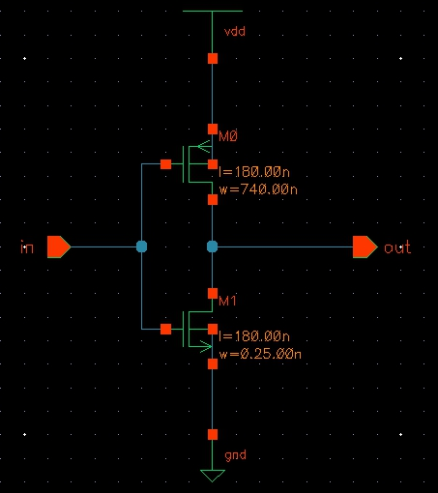

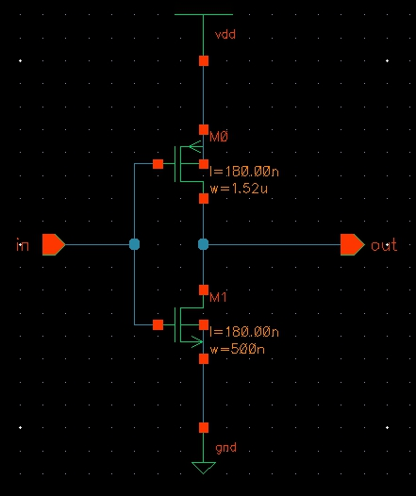

**C.【Layout view】(INV_X1 & INV_X2 )**

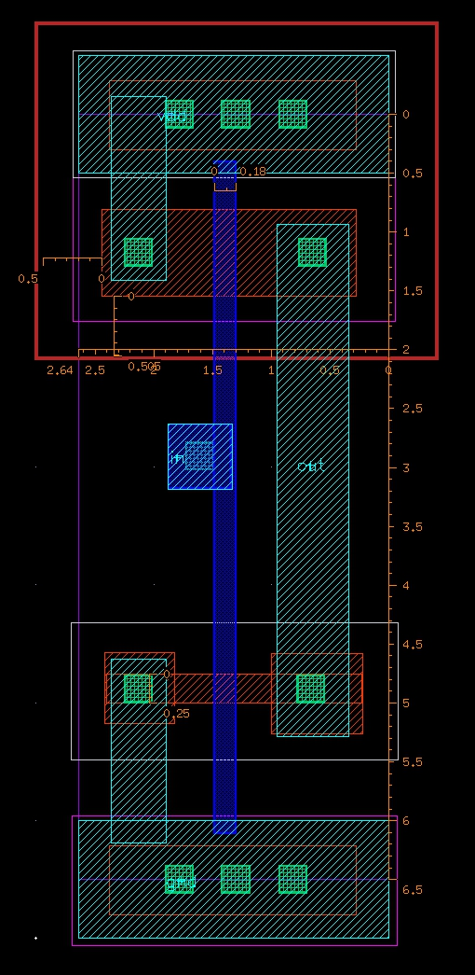

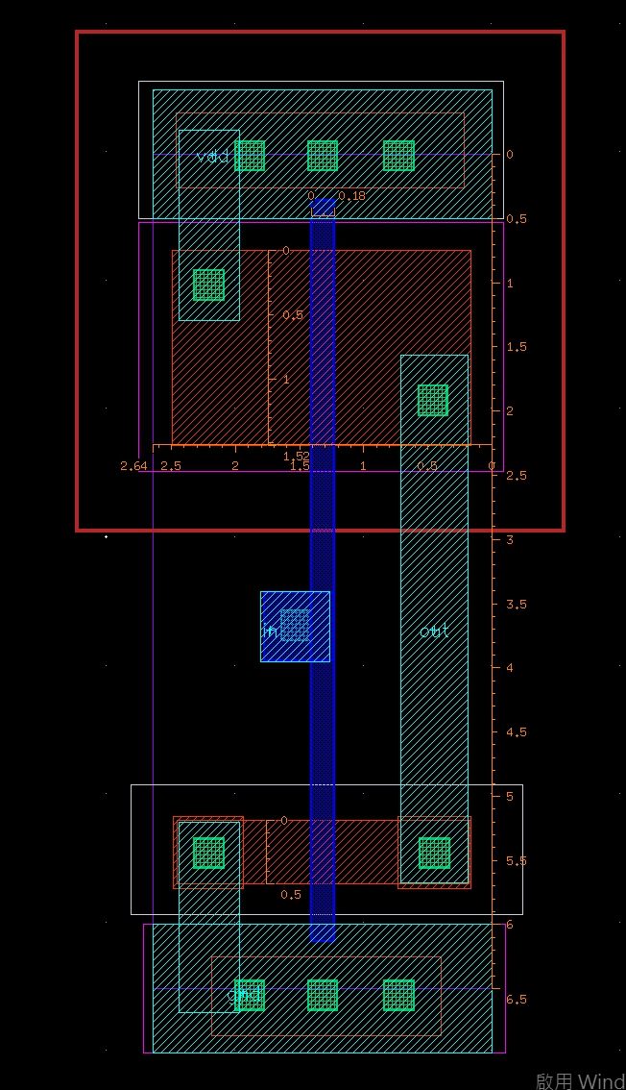

**D.【DRC successful view】(INV_X1 & INV_X2 )**

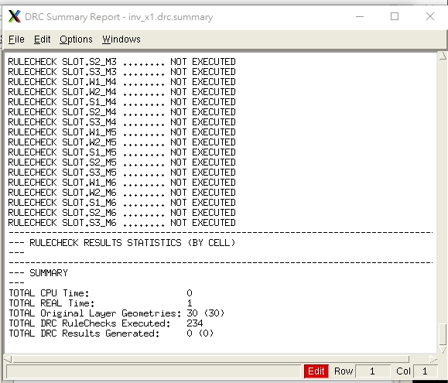

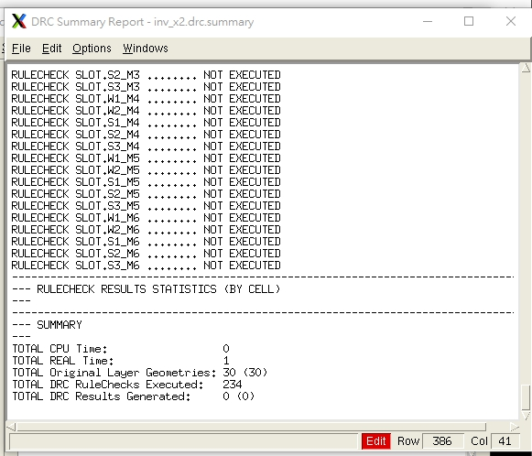

**E.【LVS successful view】(INV_X1 & INV_X2 )**

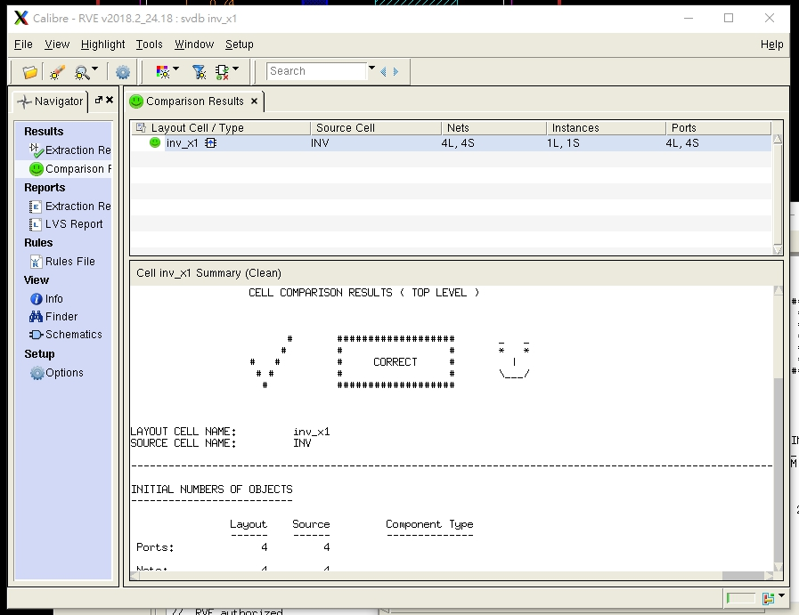

**F.【Pre-layout and Post-layout simulation waveforms】**

**F-1.(Hspice, Pre-layout) (INV_X1 & INV_X2 )**

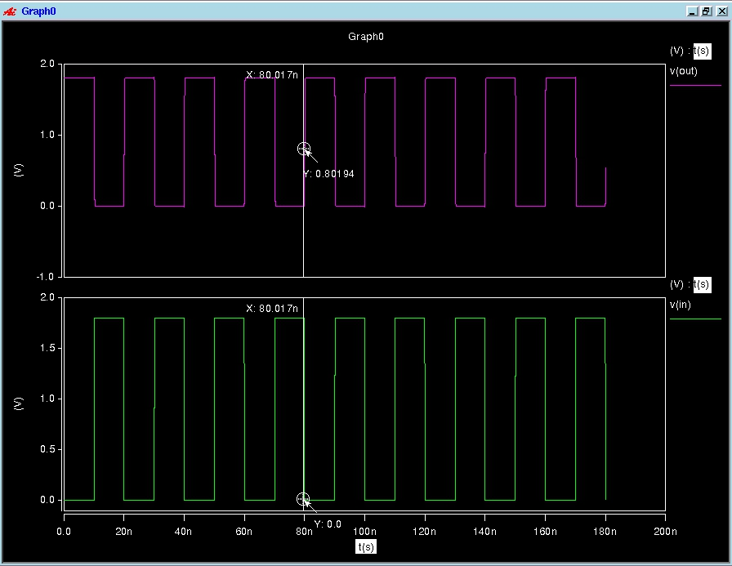

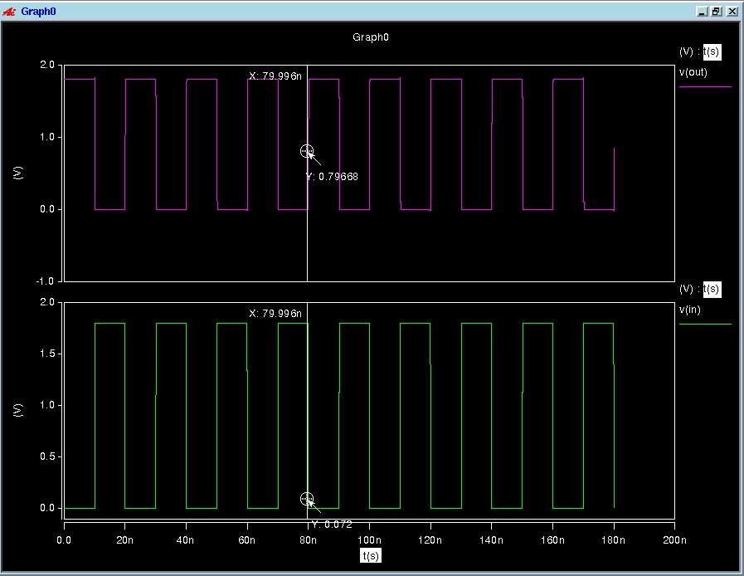

**F-2.(Hspice, Post-layout) (INV_X1 & INV_X2 )**

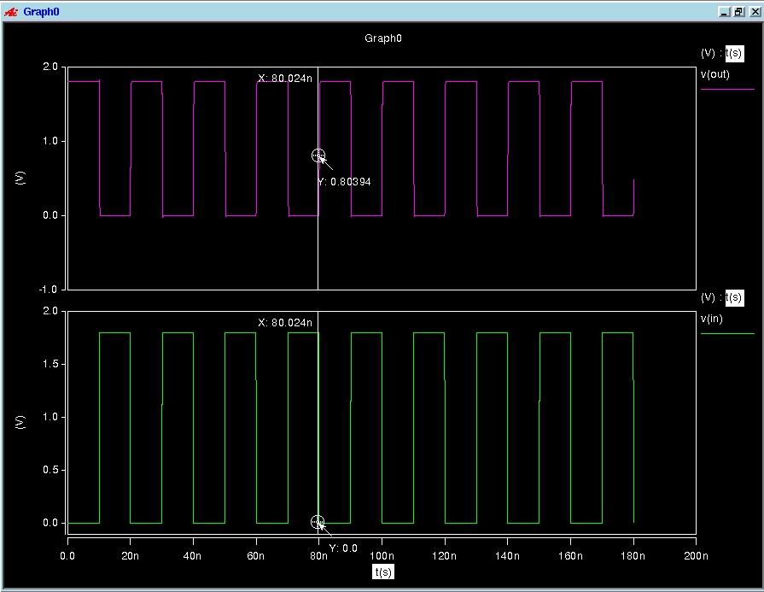

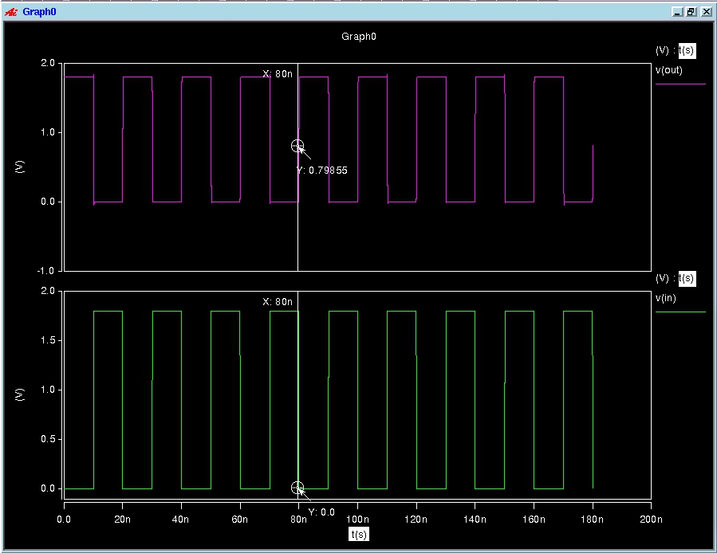

**F-3.(Nanosim, Pre-layout) (INV_X1 & INV_X2 )**

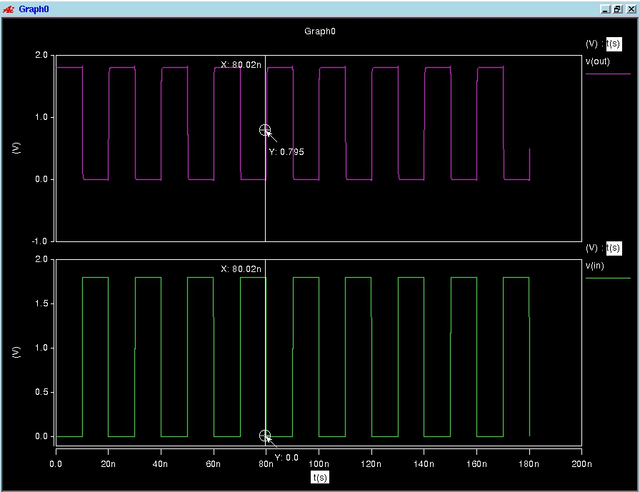

**F-4.(Nanosim, Post-layout) (INV_X1 & INV_X2 )**

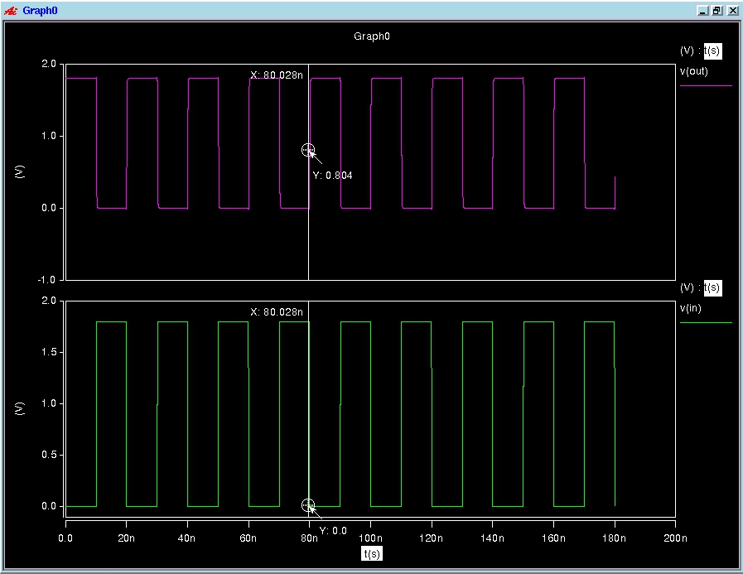

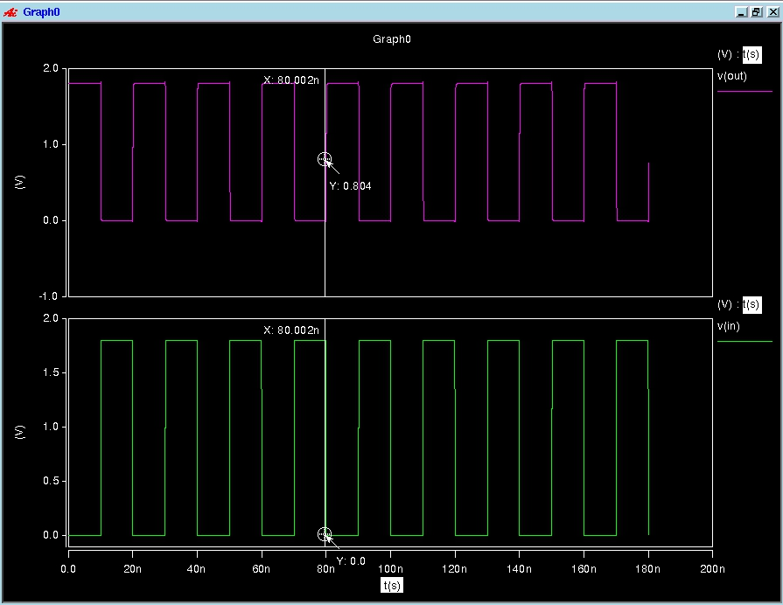

## NAND2

**A.【Compare the Results of Pre-simulation and Post-simulation in both Hspice and Nanosim simulation】**

**《NAND_X1》**

|  |  |  |  |  |  |  |  |  |  |  |  |
| --- | --- | --- | --- | --- | --- | --- | --- | --- | --- | --- | --- |
| Hspice Simulation (Pre-simulation)------Input (worse-case) Measurement | | | | | | | | | | | |
| Cload | Temp  (℃) | Process  Corner | cgtot(輸入電容) | | | | Propagation  Delay | Static Power  (Watts) | Dynamic Power (Watts) | | |
| **PMOS** | | **NMOS** | | **max** | **min** | **Avg** |
| 0.01pF | 25℃ | TT | in1 | in2 | in1 | in2 | 114.1141p | 42.6361p | 307.5871u | 21.5679p | 1.0926u |
| 1.6584f | 863.5891a | 539.7876a | 281.6760a | Tphl = 114.1141pTplh = 84.3892p |

|  |  |  |  |  |  |  |  |  |  |  |  |
| --- | --- | --- | --- | --- | --- | --- | --- | --- | --- | --- | --- |
| Hspice Simulation (Post-simulation) ------Input (worse-case) Measurement | | | | | | | | | | | |
| Cload | Temp  (℃) | Process  Corner | cgtot(輸入電容) | | | | Propagation  Delay | Static Power  (Watts) | Dynamic Power (Watts) | | |
| **PMOS** | | **NMOS** | | **max** | **min** | **Avg** |
| 0.01pF | 25℃ | TT | in1 | in2 | in1 | in2 | 120.2148p | 127.9642p | 299.6521u | -1.7508n | 1.0895u |
| 1.6584f | 863.5891a | 539.7876a | 281.6760a | Tphl = 120.2148p  Tplh =83.9913p |

|  |  |  |  |  |  |  |  |  |  |  |
| --- | --- | --- | --- | --- | --- | --- | --- | --- | --- | --- |
| Nanosim Simulation (Pre-simulation) ------Input (worse-case) Measurement | | | | | | | | | | |
| Cload | Temp  (℃) | Process  Corner | Average  Capacitive  Current  (A) | Dynamic  Power  (Watts) | Average  Wasted  Current  (A) | Static  Power  (Watts) | Average  Static  Wasted  Current | Leakage  Power  (Watts) | Average  Dynamic  Wasted  Current  (A) | Short  Power  (Watts) |
| 0.01pF | 25℃ | TT | -1.153822 uA |  | -0.003031 uA |  | -0.000018 uA |  | -0.003013 uA |  |

|  |  |  |  |  |  |  |  |  |  |  |  |
| --- | --- | --- | --- | --- | --- | --- | --- | --- | --- | --- | --- |
| Nanosim Simulation (Post-simulation) ------Input (worse-case) Measurement | | | | | | | | | | | |
| Cload | Temp  (℃) | Process  Corner | Average  Capacitive  Current  (A) | Dynamic  Power  (Watts) | Average  Wasted  Current  (A) | Static  Power  (Watts) | Average  Static  Wasted  Current | Leakage  Power  (Watts) | | Average  Dynamic  Wasted  Current  (A) | Short  Power  (Watts) |
| 0.01pF | 25℃ | TT | -1.291523 uA |  | -0.000820 uA |  | -0.000017 uA |  | -0.000803 uA | |  |

**《NAND_X2》**

|  |  |  |  |  |  |  |  |  |  |  |  |
| --- | --- | --- | --- | --- | --- | --- | --- | --- | --- | --- | --- |
| Hspice Simulation (Pre-simulation)------Input (worse-case) Measurement | | | | | | | | | | | |
| Cload | Temp  (℃) | Process  Corner | cgtot(輸入電容) | | | | Propagation  Delay | Static Power  (Watts) | Dynamic Power (Watts) | | |
| **PMOS** | | **NMOS** | | **max** | **min** | **Avg** |
| 0.01pF | 25℃ | TT | in1 | in2 | in1 | in2 | 84.1917p | 42.6357p | 509.3841u | 34.5032p | 1.3658u |
| 3.4064f | 1.7764f | 1.0796f | 566.8137a | Tphl = 84.1917p  Tplh = 59.7139p |

|  |  |  |  |  |  |  |  |  |  |  |  |
| --- | --- | --- | --- | --- | --- | --- | --- | --- | --- | --- | --- |
| Hspice Simulation (Post-simulation) ------Input (worse-case) Measurement | | | | | | | | | | | |
| Cload | Temp  (℃) | Process  Corner | cgtot(輸入電容) | | | | Propagation  Delay | Static Power  (Watts) | Dynamic Power (Watts) | | |
| **PMOS** | | **NMOS** | | **max** | **min** | **Avg** |
| 0.01pF | 25℃ | TT | in1 | in2 | in1 | in2 | 79.8216p | 42.6327p | 496.1426u | 34.5027p | 1.3578u |
| 3.4064f | 1.7764f | 1.0796f | 566.8137a | Tphl = 79.8216p  Tplh = 55.7670p |

|  |  |  |  |  |  |  |  |  |  |  |
| --- | --- | --- | --- | --- | --- | --- | --- | --- | --- | --- |
| Nanosim Simulation (Pre-simulation) ------Input (worse-case) Measurement | | | | | | | | | | |
| Cload | Temp  (℃) | Process  Corner | Average  Capacitive  Current  (A) | Dynamic  Power  (Watts) | Average  Wasted  Current  (A) | Static  Power  (Watts) | Average  Static  Wasted  Current | Leakage  Power  (Watts) | Average  Dynamic  Wasted  Current  (A) | Short  Power  (Watts) |
| 0.01pF | 25℃ | TT | -1.517472 uA |  | -0.014815 uA |  | -0.000005 uA |  | -0.014810 uA |  |

|  |  |  |  |  |  |  |  |  |  |  |  |
| --- | --- | --- | --- | --- | --- | --- | --- | --- | --- | --- | --- |
| Nanosim Simulation (Post-simulation) ------Input (worse-case) Measurement | | | | | | | | | | | |
| Cload | Temp  (℃) | Process  Corner | Average  Capacitive  Current  (A) | Dynamic  Power  (Watts) | Average  Wasted  Current  (A) | Static  Power  (Watts) | Average  Static  Wasted  Current | Leakage  Power  (Watts) | | Average  Dynamic  Wasted  Current  (A) | Short  Power  (Watts) |
| 0.01pF | 25℃ | TT | -1.535756 uA |  | -0.004818 uA |  | -0.000006 uA |  | -0.004812 uA | |  |

**B.【schematic view】(NAND_X1 & NAND_X2)**

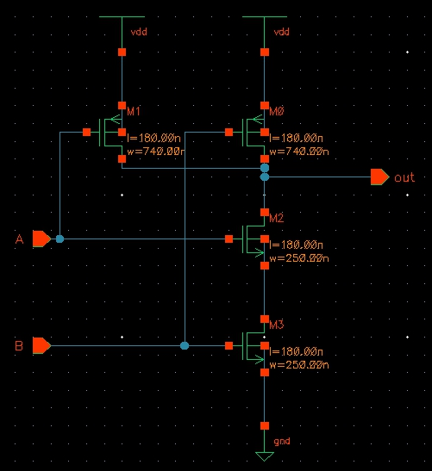

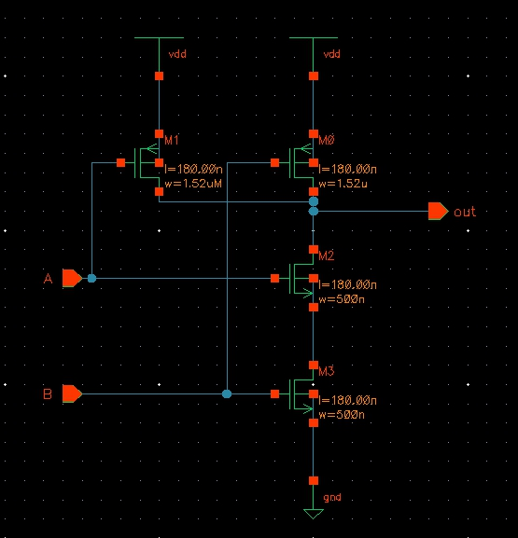

**C.【Layout view】(NAND_X1 & NAND_X2)**

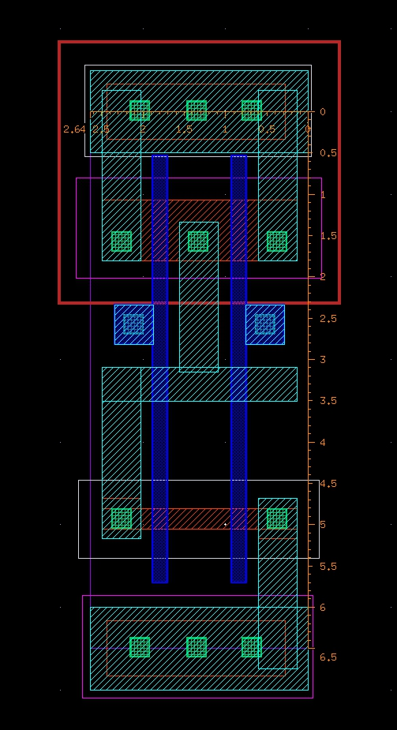

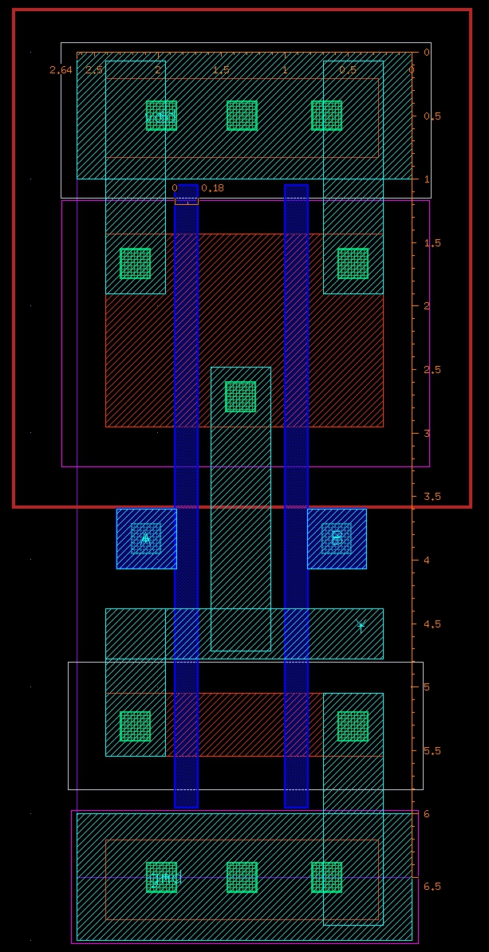

**D.【DRC successful view】(NAND_X1 & NAND_X2)**

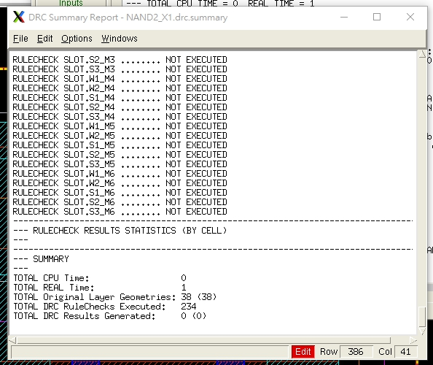

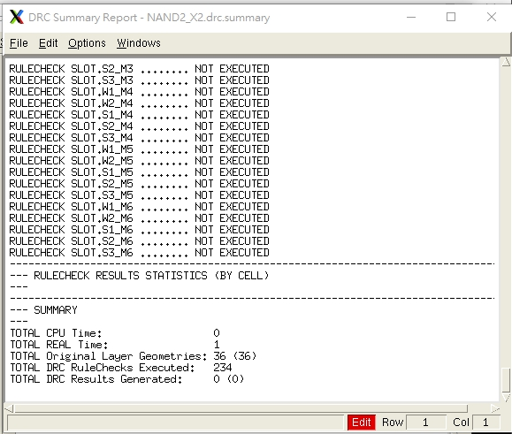

**E.【LVS successful view】(NAND_X1 & NAND_X2)**

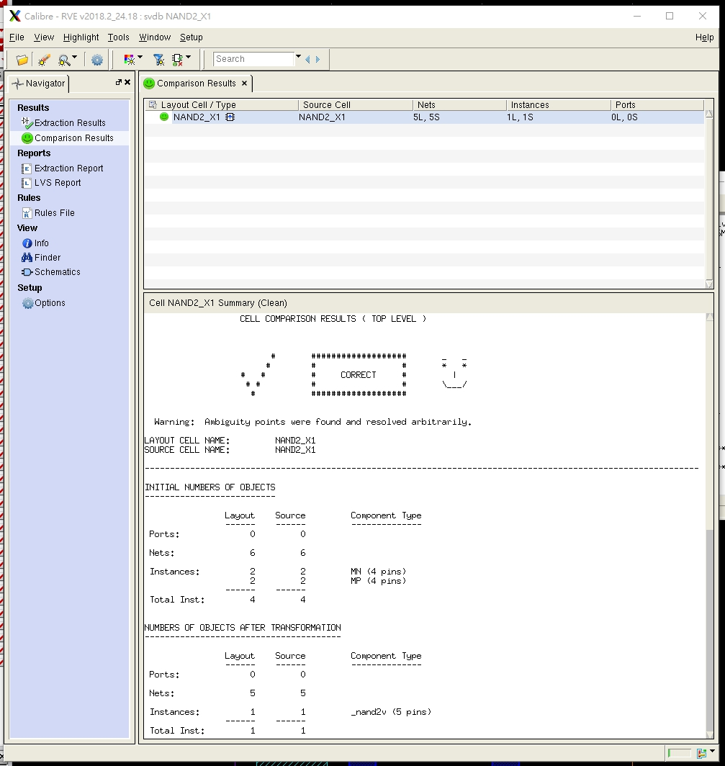

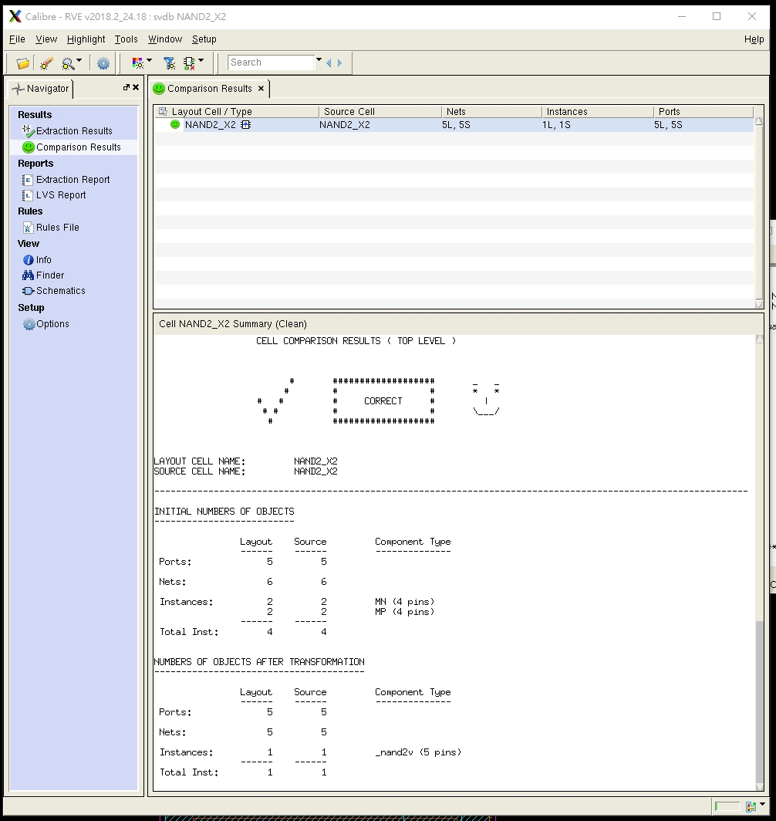

**F.【Pre-layout and Post-layout simulation waveforms】**

**F-1.(Hspice, Pre-layout) (NAND_X1 & NAND_X2)**

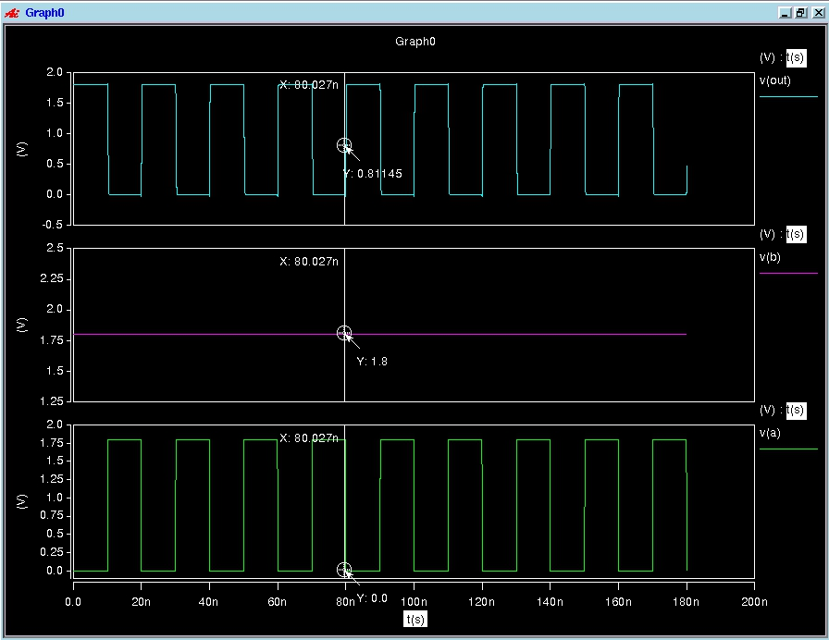

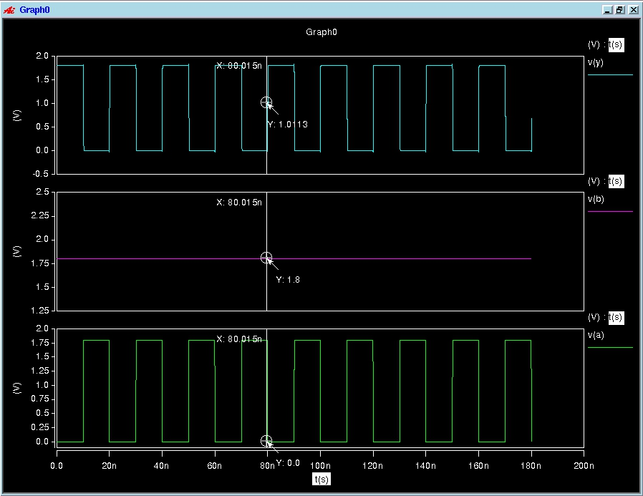

**F-2.(Hspice, Post-layout) (NAND_X1 & NAND_X2)**

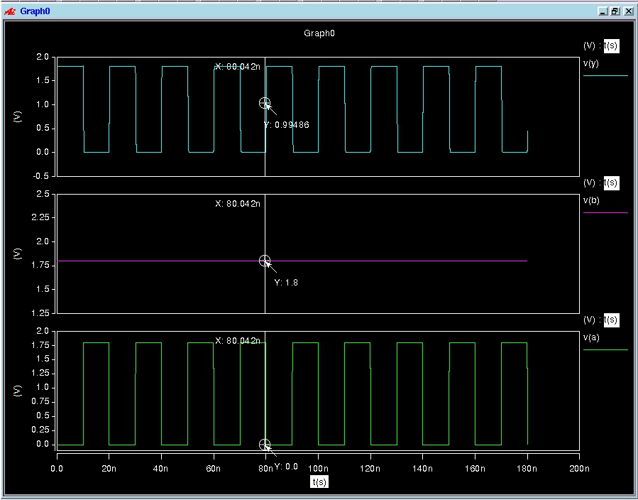

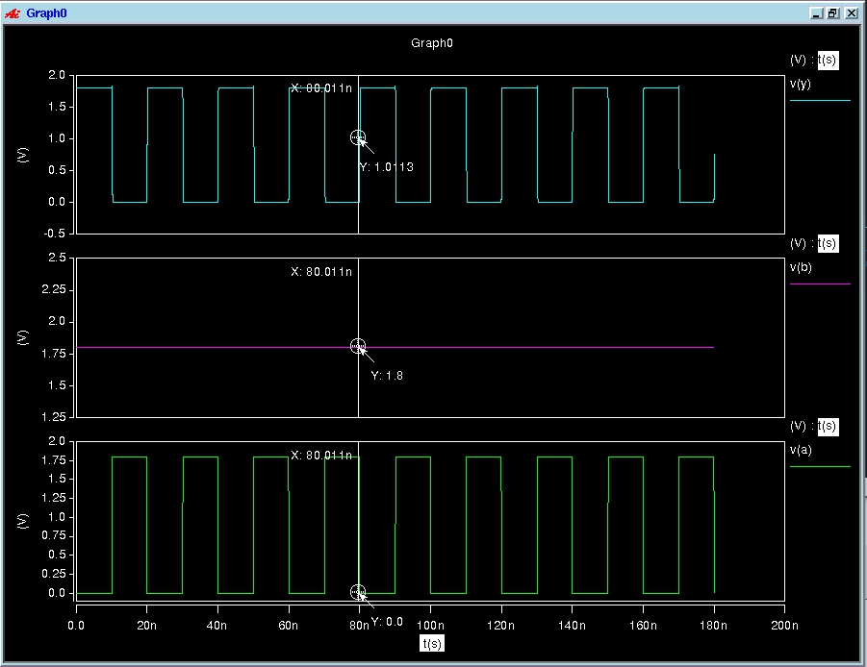

**F-3.(Nanosim, Pre-layout) (NAND_X1 & NAND_X2)**

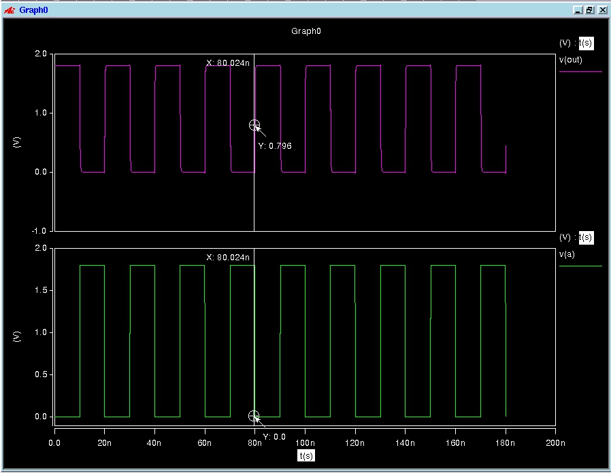

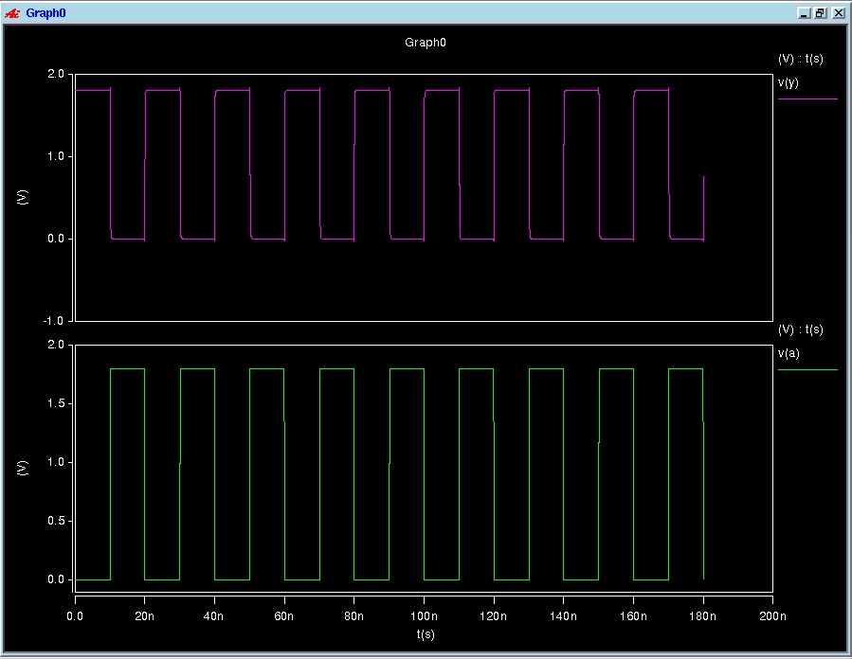

**F-4.(Nanosim, Post-layout) (NAND_X1 & NAND_X2)**

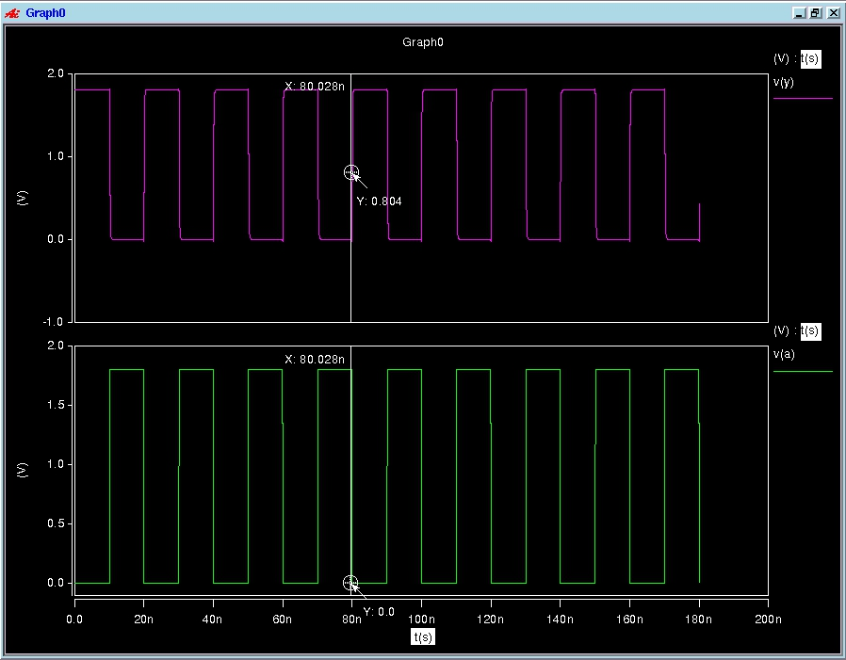

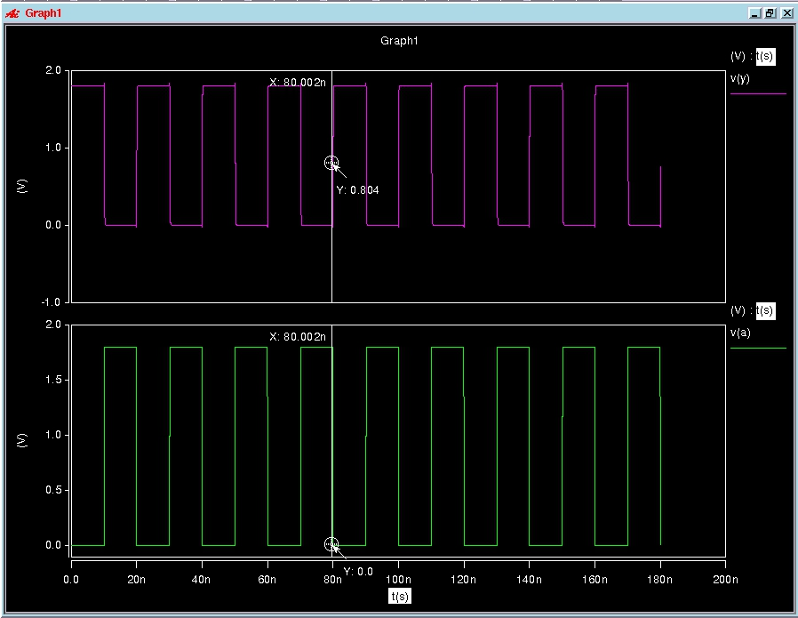

## NOR2

**A.【Compare the Results of Pre-simulation and Post-simulation in both Hspice and Nanosim simulation】**

**《NOR_X1》**

|  |  |  |  |  |  |  |  |  |  |  |  |
| --- | --- | --- | --- | --- | --- | --- | --- | --- | --- | --- | --- |
| Hspice Simulation (Pre-simulation)------Input (worse-case) Measurement | | | | | | | | | | | |
| Cload | Temp  (℃) | Process  Corner | cgtot(輸入電容) | | | | Propagation  Delay | Static Power  (Watts) | Dynamic Power (Watts) | | |
| **PMOS** | | **NMOS** | | **max** | **min** | **Avg** |
| 0.01pF | 25℃ | TT | in1 | in2 | in1 | in2 | 137.6592p | 254.8335p | 295.4445u | 10.7570p | 1.1253u |
| 1.6584f | 1.6584f | 281.6760a | 281.6760a | Tphl = 88.7582p  Tplh = 137.6592p |

|  |  |  |  |  |  |  |  |  |  |  |  |
| --- | --- | --- | --- | --- | --- | --- | --- | --- | --- | --- | --- |
| Hspice Simulation (Post-simulation) ------Input (worse-case) Measurement | | | | | | | | | | | |
| Cload | Temp  (℃) | Process  Corner | cgtot(輸入電容) | | | | Propagation  Delay | Static Power  (Watts) | Dynamic Power (Watts) | | |
| **PMOS** | | **NMOS** | | **max** | **min** | **Avg** |
| 0.01pF | 25℃ | TT | in1 | in2 | in1 | in2 | 153.8169p | 255.0283p | 260.1388u | 10.7962p | 1.1819u |
| 1.6584f | 1.6584f | 281.6760a | 281.6760a | Tphl = 90.7495p  Tplh = 153.8169p |

|  |  |  |  |  |  |  |  |  |  |  |
| --- | --- | --- | --- | --- | --- | --- | --- | --- | --- | --- |
| Nanosim Simulation (Pre-simulation) ------Input (worse-case) Measurement | | | | | | | | | | |
| Cload | Temp  (℃) | Process  Corner | Average  Capacitive  Current  (A) | Dynamic  Power  (Watts) | Average  Wasted  Current  (A) | Static  Power  (Watts) | Average  Static  Wasted  Current | Leakage  Power  (Watts) | Average  Dynamic  Wasted  Current  (A) | Short  Power  (Watts) |
| 0.01pF | 25℃ | TT | -1.078994 uA |  | -0.004657 uA |  | -0.000008 uA |  | -0.004649 uA |  |

|  |  |  |  |  |  |  |  |  |  |  |  |
| --- | --- | --- | --- | --- | --- | --- | --- | --- | --- | --- | --- |
| Nanosim Simulation (Post-simulation) ------Input (worse-case) Measurement | | | | | | | | | | | |
| Cload | Temp  (℃) | Process  Corner | Average  Capacitive  Current  (A) | Dynamic  Power  (Watts) | Average  Wasted  Current  (A) | Static  Power  (Watts) | Average  Static  Wasted  Current | Leakage  Power  (Watts) | | Average  Dynamic  Wasted  Current  (A) | Short  Power  (Watts) |
| 0.01pF | 25℃ | TT | -1.306928 uA |  | -0.003036 uA |  | 0.000000 uA |  | -0.003036 uA | |  |

**《NOR _X2》**

|  |  |  |  |  |  |  |  |  |  |  |  |
| --- | --- | --- | --- | --- | --- | --- | --- | --- | --- | --- | --- |
| Hspice Simulation (Pre-simulation)------Input (worse-case) Measurement | | | | | | | | | | | |
| Cload | Temp  (℃) | Process  Corner | cgtot(輸入電容) | | | | Propagation  Delay | Static Power  (Watts) | Dynamic Power (Watts) | | |
| **PMOS** | | **NMOS** | | **max** | **min** | **Avg** |
| 0.01pF | 25℃ | TT | in1 | in2 | in1 | in2 | 90.7300p | 85.2708p | 493.3548u | 17.1090p | 1.4104u |
| 3.4064f | 3.4064f | 566.8137a | 566.8137a | Tphl = 65.6519p  Tplh = 90.7300p |

|  |  |  |  |  |  |  |  |  |  |  |  |
| --- | --- | --- | --- | --- | --- | --- | --- | --- | --- | --- | --- |
| Hspice Simulation (Post-simulation) ------Input (worse-case) Measurement | | | | | | | | | | | |
| Cload | Temp  (℃) | Process  Corner | cgtot(輸入電容) | | | | Propagation  Delay | Static Power  (Watts) | Dynamic Power (Watts) | | |
| **PMOS** | | **NMOS** | | **max** | **min** | **Avg** |
| 0.01pF | 25℃ | TT | in1 | in2 | in1 | in2 | 90.7300p | 85.2708p | 493.3548u | 17.1090p | 1.4104u |
| 3.4064f | 3.4064f | 566.8137a | 566.8137a | Tphl =  Tplh = |

|  |  |  |  |  |  |  |  |  |  |  |
| --- | --- | --- | --- | --- | --- | --- | --- | --- | --- | --- |
| Nanosim Simulation (Pre-simulation) ------Input (worse-case) Measurement | | | | | | | | | | |
| Cload | Temp  (℃) | Process  Corner | Average  Capacitive  Current  (A) | Dynamic  Power  (Watts) | Average  Wasted  Current  (A) | Static  Power  (Watts) | Average  Static  Wasted  Current | Leakage  Power  (Watts) | Average  Dynamic  Wasted  Current  (A) | Short  Power  (Watts) |
| 0.01pF | 25℃ | TT | -1.364383 uA |  | -0.011423 uA |  | 0.000000 uA |  | -0.011423 uA |  |

|  |  |  |  |  |  |  |  |  |  |  |  |
| --- | --- | --- | --- | --- | --- | --- | --- | --- | --- | --- | --- |
| Nanosim Simulation (Post-simulation) ------Input (worse-case) Measurement | | | | | | | | | | | |
| Cload | Temp  (℃) | Process  Corner | Average  Capacitive  Current  (A) | Dynamic  Power  (Watts) | Average  Wasted  Current  (A) | Static  Power  (Watts) | Average  Static  Wasted  Current | Leakage  Power  (Watts) | | Average  Dynamic  Wasted  Current  (A) | Short  Power  (Watts) |
| 0.01pF | 25℃ | TT |  |  |  |  |  |  |  | |  |

**B.【schematic view】(NOR_X1 & NOR _X2)**

**C.【Layout view】(NOR _X1 & NOR _X2)**

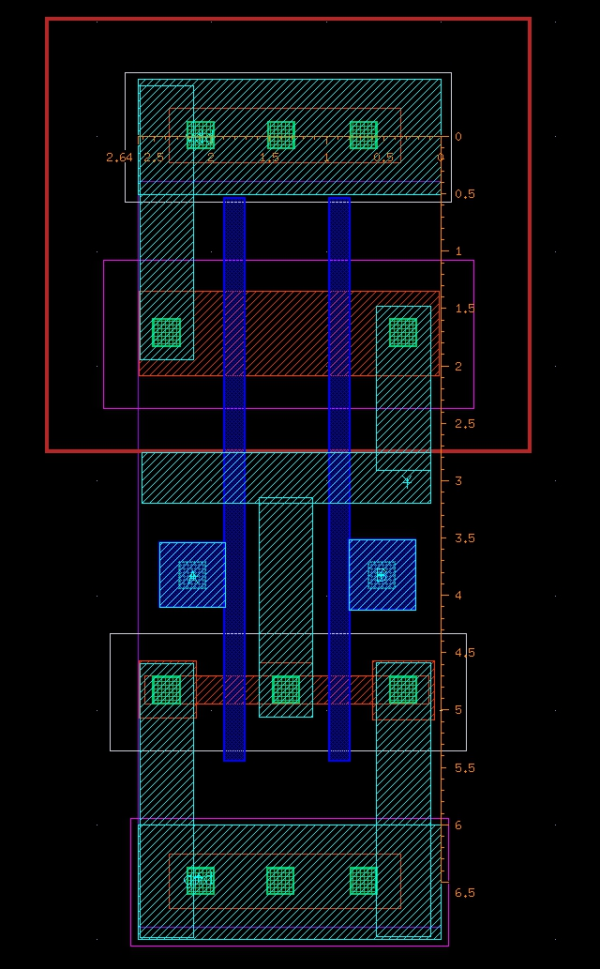

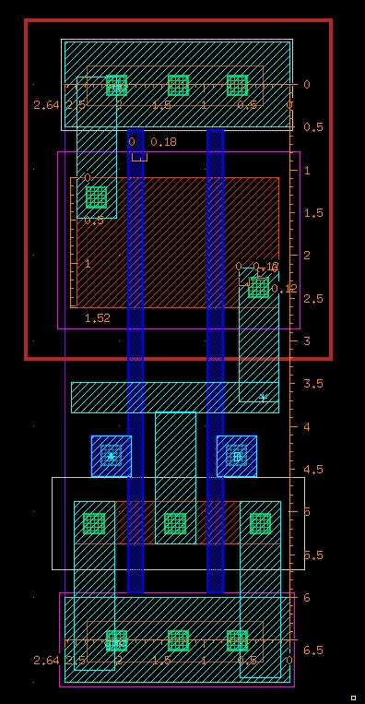

**D.【DRC successful view】(NOR _X1 & NOR _X2)**

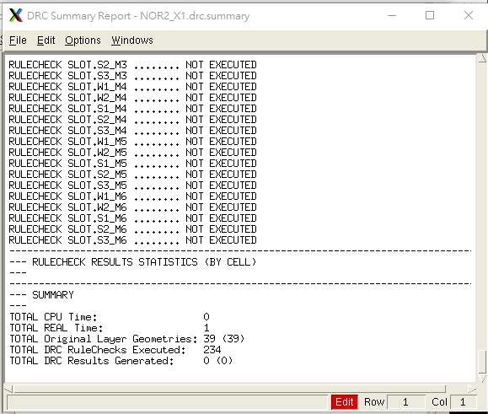

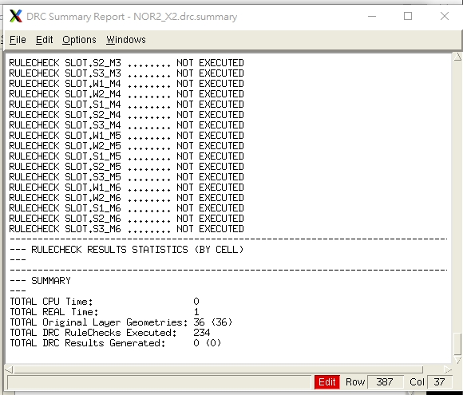

**E.【LVS successful view】(NOR _X1 & NOR _X2)**

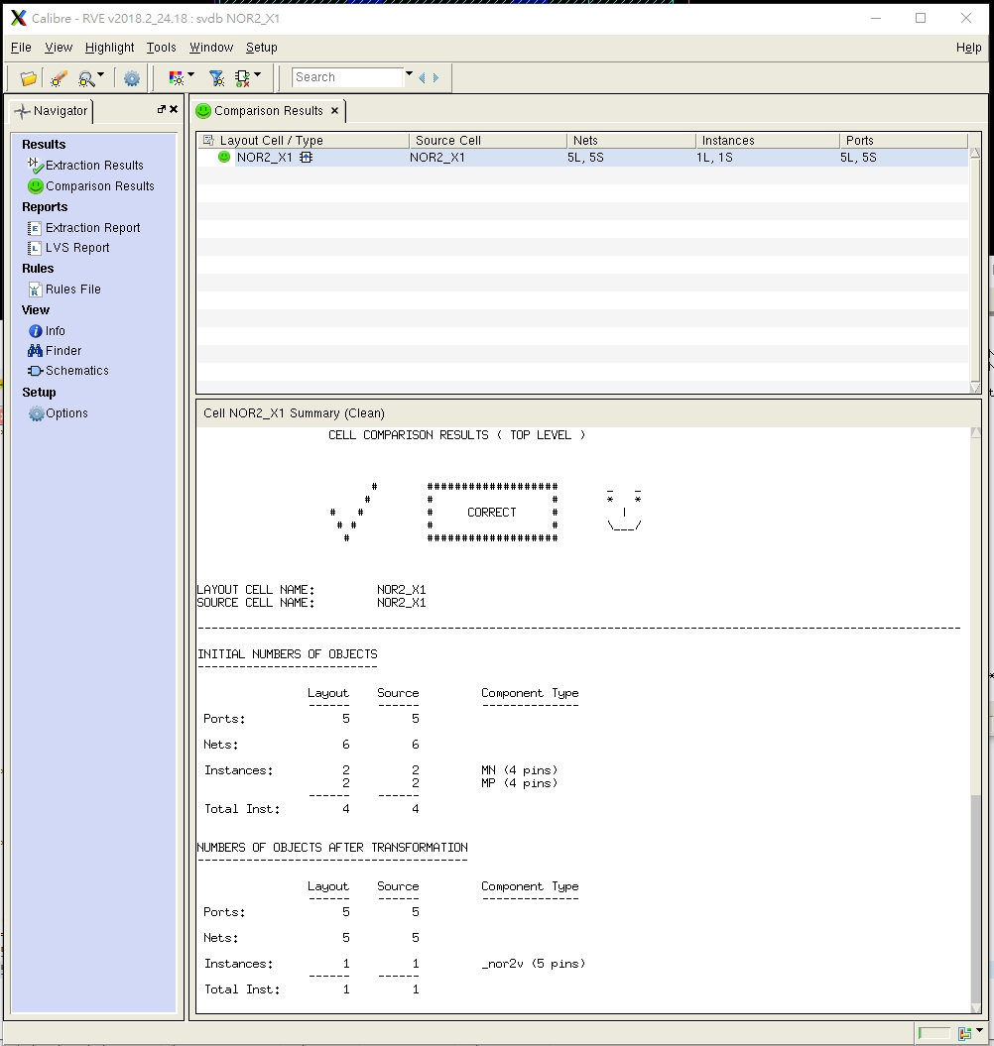

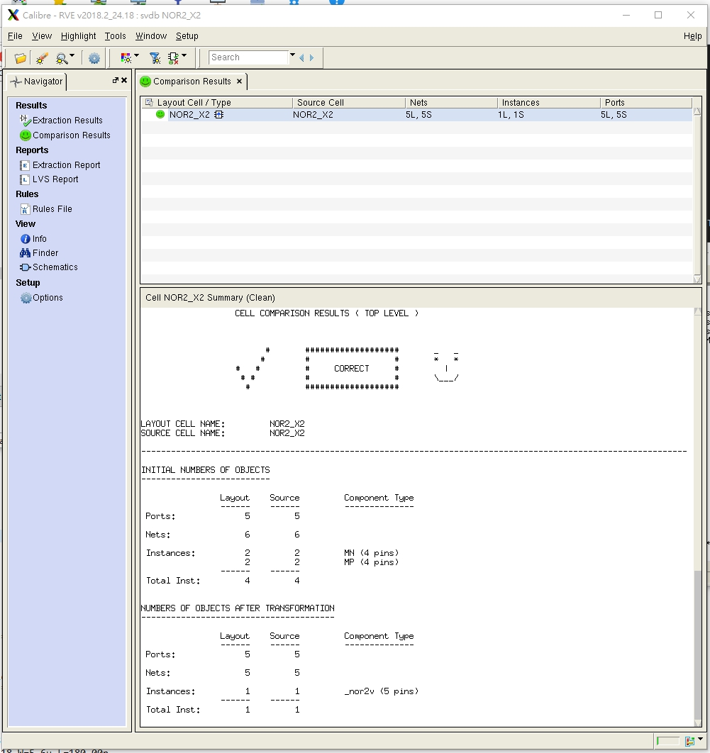

**F.【Pre-layout and Post-layout simulation waveforms】**

**F-1.(Hspice, Pre-layout) (NOR _X1 & NOR _X2)**

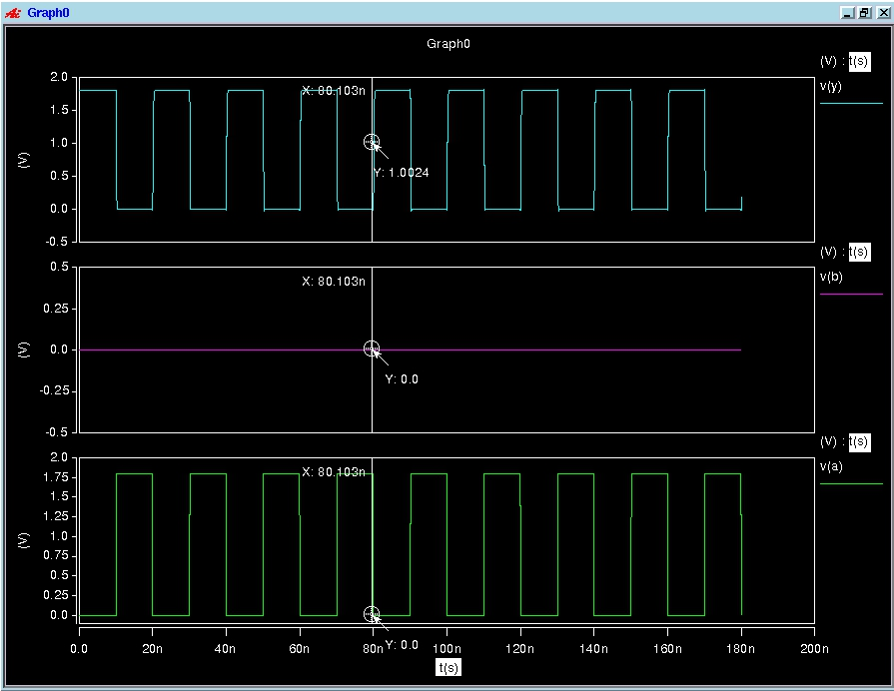

**F-2.(Hspice, Post-layout) (NOR _X1 & NOR _X2)**

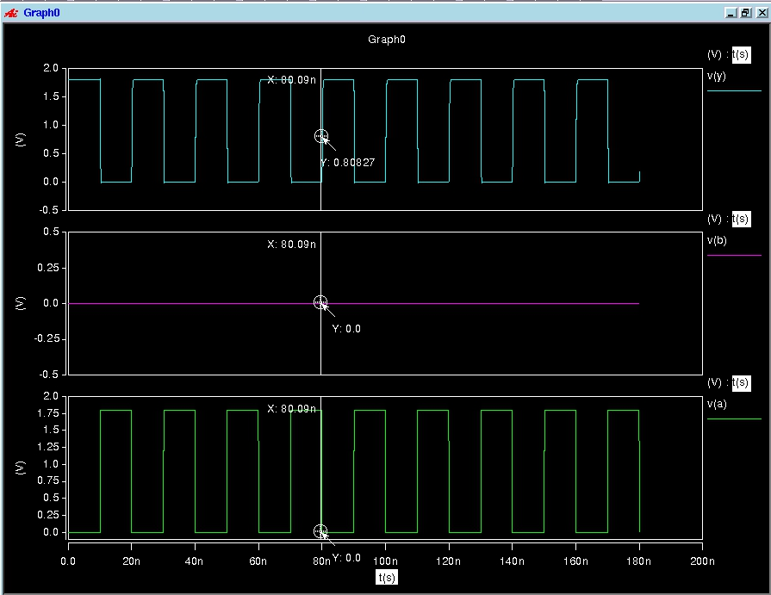

**F-3.(Nanosim, Pre-layout) (NOR _X1 & NOR _X2)**

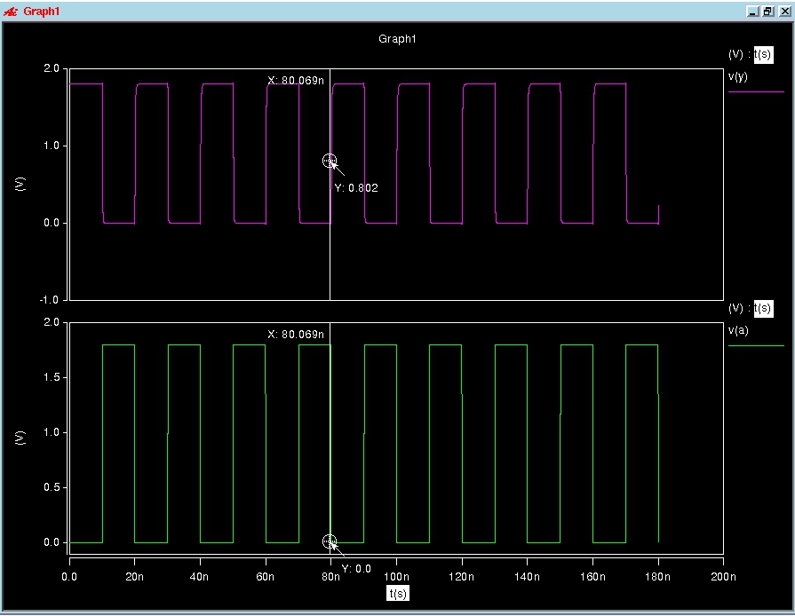

**F-4.(Nanosim, Post-layout) (NOR _X1 & NOR _X2)**

